LMS TESTING

1. Add new button in Daily tracker is not working.
2. While scheduling a meeting online Venue field is showing mandatory.

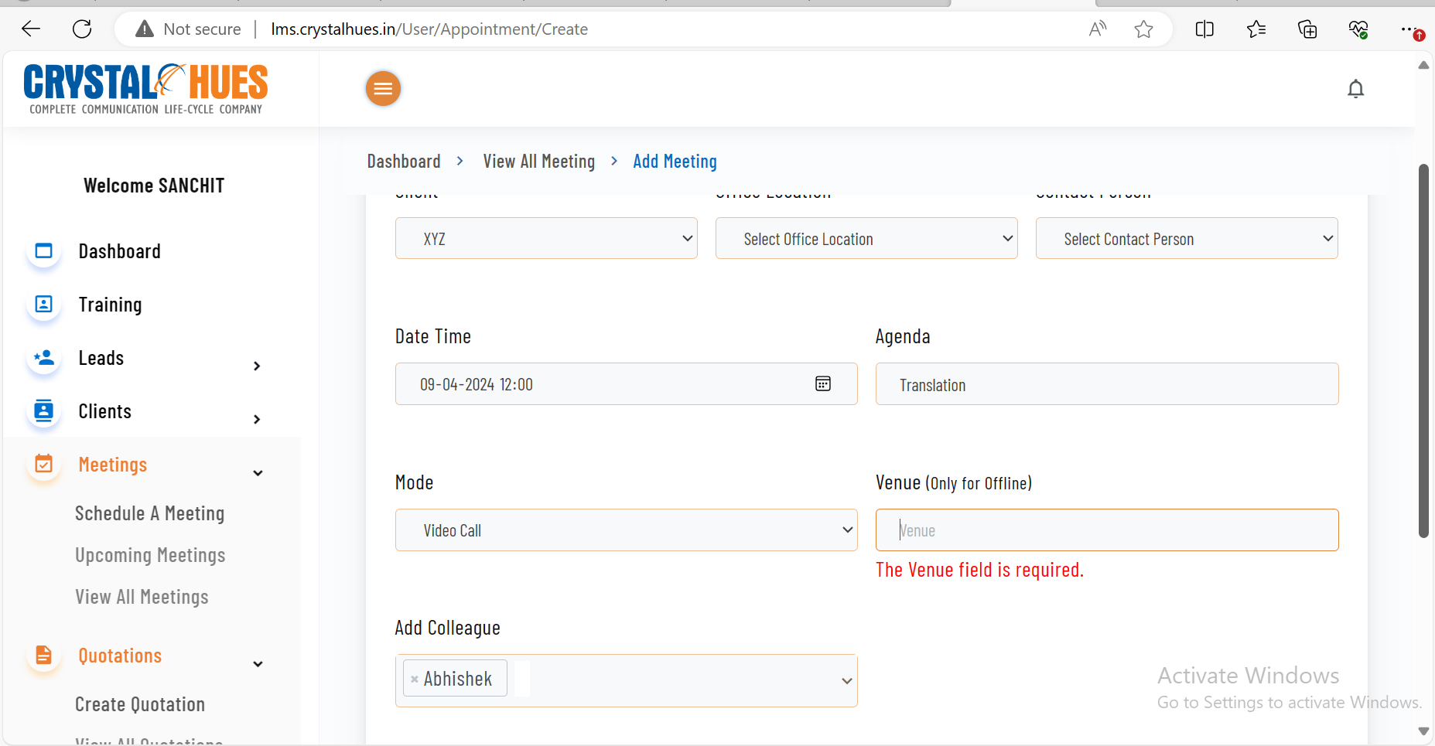

1. In view all meeting section while trying to add remarks field is showing blank, there is no place to add remarks.

1. While submitting the quotation without Vendor proof, no msg pop up, directly went on quotation 1st page.
2. Find error while adding assignments

1. Year not coming in report section.

